NYSSLS Daily Lesson Plan
Instructional Unit:  Weather and Climate –  Air masses, Fronts and Weather  Lesson: Atmospheric Layers |  |  |  |  |  | Period(s) of Unit:  6 Periods |  | Date:
Materials/Resources/Links:  Atmospheric Layer Data |  |  |  |  |  |  |  | Course:  Earth and Space Science
Special Notes for Lesson:

ANCHORING PHENOMINON: Why is there snow and ice on the tops of tall mountains even at the equator.

Standards:
Science and Engineering Practices  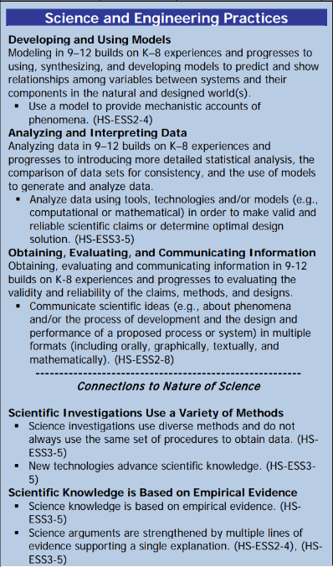 |  |  | Disciplinary Core Idea(s)  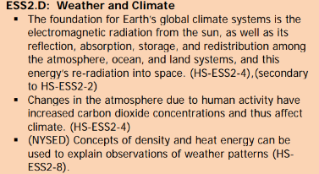 |  |  |  | Cross Cutting Concepts  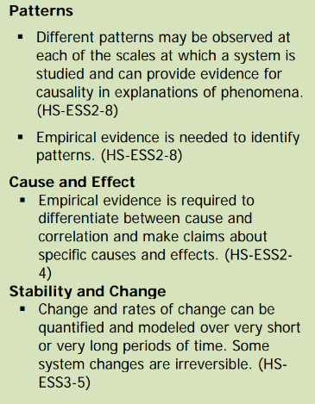
Performance Level
NYS Level 5 | NYS Level 4 |  |  | NYS Level 3 | NYS Level 2 |  |  | NYS Level 1
Collect and analyze global and regional weather data using tools, technologies, and /or models to communicate in multiple formats how the movement and interactions of airmasses result in changes in weather conditions. | Evaluate data and communicate information to explain how the movement and interactions of air masses result in changes in weather conditions |  |  | Evaluate data and communicate information to identify patterns of movement and/or the resulting changes in weather conditions. | Use data to identify the patterns of movement or the interactions of air masses and the resulting change in weather conditions  or to identify factors that drive the movement of air masses or from given weather conditions, identify evidence from maps that support these conditions. |  |  | Use data and/or patterns of movement and interactions of air masses to identify the resulting changes in weather conditions or identify one factor that drives the movement of air masses or from those provided, use evidence from maps to account for weather conditions or given weather conditions, identify evidence found on maps that account for one of these conditions.
Clarification Statement  Examples of evidence sources could include station models, surface weather maps, satellite images, radar and accepted forecast models. Emphasis should focus on communicating how the uneven heating of the Earth’s surface at frontal boundaries and resulting weather phenomena. |  |  |  |  | Assessment Boundary  Analysis is limited to surface weather maps and general weather patterns associated with High and Low pressure systems
Connection to Anchoring Phenomenon:

By graphing temperature, humidity and air pressure trends in the atmosphere, students will be able to see that the atmosphere is made of layers based on temperature trends. After analysis of humidity and air pressure trends students will also be able to determine why most weather takes place in the first layer of the atmosphere.

Essential Question(s):

After the students graph the altitude/temperature data the teacher will provide the names of the different layers. Students will be asked to wonder what defines one layer from the other? The teacher will also provide the composition of the atmosphere.

Why does temperature increase in the stratosphere?

How does water vapor concentration change with altitude?

How does Air pressure change with altitude?

Instructional Strategies & Learning Tasks: Engage, Explore, Explain, Elaborate, Evaluate
Engage: images, video clip or data… |  | Students will be asked to draw what they think the atmosphere would look like if they were able to see it, from the surface of the earth into space where there is no atmosphere.
Explore: Students investigate, experiment, hands-on activity…. |  | Students will enter Altitude/Temperature data into excel and make a graph. They will also do the same for altitude/air pressure and altitude/water vapor concentration.
Explain: Students share their observations and evidence to explain their understanding…possible whole group/class discussion… |  | After the teacher gives the names of each layer students will explain what determines where one layer begins and another layer ends.  They will also explain the relationship between altitude and air pressure and altitude and water vapor concentration.
Elaborate: Students apply the science concepts they’ve just learned… |  | Students will be told by the teacher that most weather (clouds/rain/snow) take place in the Troposphere. By analyzing the graphs students will come up with reasons why.
Evaluate (Formative Assessment): Student learning is evaluated. |  | Students will be evaluated by teacher questions as well as a test or quiz.

Copy and paste student worksheets below:

